Student Name: Hediyeh Kadkhodaei
Student ID: 240417844
Department: Computer Engineering

Dear Professor,

This project is my midterm project and it is called “Memory Stack Game”.

The project is a small memory puzzle game developed using the C++ programming language and the Stack data structure.

In this game, the user sees a word for a few seconds and must memorize it. After the word disappears, the user should type the reversed form of the word. The program uses the Stack data structure based on the LIFO (Last In, First Out) principle to reverse the letters and check the user’s answer.

The project includes:

- Easy, Medium, and Hard levels
- Random word selection
- Correct and wrong answer checking
- Try again option
- Exit option

The main purpose of this project is to demonstrate how Stack works in a simple and interactive game format.

Sample Output
MEMORY STACK GAME
In this game, you will see a word.
When the word is reversed, it becomes another meaningful word.
You should memorize the word and type its reversed form.
This game uses Stack and LIFO principle.
LIFO means Last In, First Out.

Choose a Level:
1. Easy
2. Medium
3. Hard
4. Exit
Enter your choice: 1

Memorize this word: loop
You have 3 seconds...

Now type the reversed word: pool

Correct! Well done.
Reversed word: pool

Play again? (y/n): n

Thank you for playing!

Now type the reversed word: evil
Wrong answer! Try again.
Enter the reversed word: live
Correct! Well done.

1. Start the program
2. Show game introduction
3. Display level menu
4. User selects a level
5. Program selects a word
6. Push word letters into Stack
7. Display word for 3 seconds
8. Clear the screen
9. Ask user to enter reversed word
10. Pop letters from Stack to create reversed word
11. Compare user answer with reversed word
12. If answer is correct, show success message
13. If answer is wrong, ask user to try again
14. Ask user if they want to play again
15. Exit the game
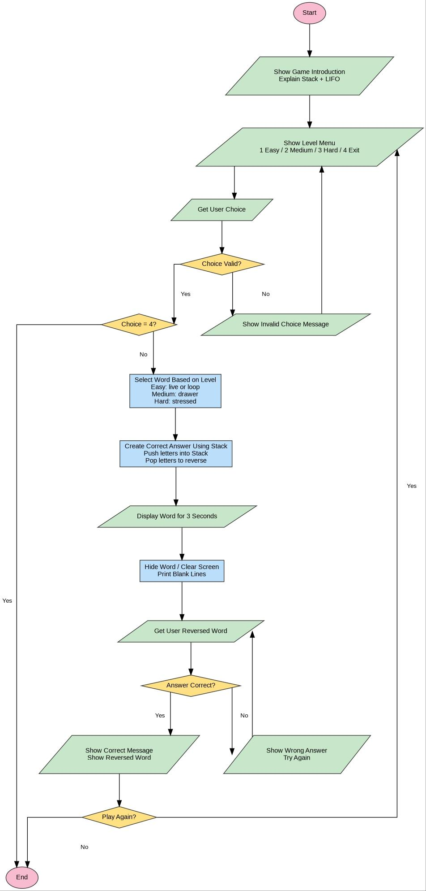

#include <iostream>
#include <stack>
#include <string>
#include <cstdlib>
#include <ctime>
#include <thread>
#include <chrono>

Using namespace std;

String reverseWithStack(string word) {
Stack<char> letters;
String reversed = “”;

For (int i = 0; i < word.length(); i++) {
Letters.push(word[i]);
}

While (!letters.empty()) {
Reversed += letters.top();
Letters.pop();
}

Return reversed;
}

Void clearScreen() {
For (int i = 0; i < 40; i++) {
Cout << endl;
}
}

Int main() {
Srand(time(0));

Char choice;
Char playAgain;
String word, answer, correctAnswer;

Cout << “=====================================\n”;
Cout << “ MEMORY STACK GAME\n”;
Cout << “=====================================\n”;
Cout << “In this game, you will see a word.\n”;
Cout << “When the word is reversed, it becomes another meaningful word.\n”;
Cout << “You should memorize the word and type its reversed form.\n”;
Cout << “This game uses Stack and LIFO principle.\n”;
Cout << “LIFO means Last In, First Out.\n\n”;

Do {
Cout << “Choose a Level:\n”;
Cout << “1. Easy\n”;
Cout << “2. Medium\n”;
Cout << “3. Hard\n”;
Cout << “4. Exit\n”;
Cout << “Enter your choice: “;
Cin >> choice;

If (choice == ‘1’) {
Int randomEasy = rand() % 2;

If (randomEasy == 0) {
Word = “live”;
} else {
Word = “loop”;
}
}
Else if (choice == ‘2’) {
Word = “drawer”;
}
Else if (choice == ‘3’) {
Word = “stressed”;
}
Else if (choice == ‘4’) {
Cout << “Exiting the game...\n”;
Break;
}
Else {
Cout << “Invalid choice! Please enter 1, 2, 3, or 4.\n\n”;
Continue;
}

correctAnswer = reverseWithStack(word);

cout << “\nMemorize this word: “ << word << endl;
cout << “You have 3 seconds...\n”;

this_thread::sleep_for(chrono::seconds(3));

clearScreen();

cout << “Now type the reversed word: “;
cin >> answer;

while (answer != correctAnswer) {
cout << “Wrong answer! Try again.\n”;
cout << “Enter the reversed word: “;
cin >> answer;
}

Cout << “\nCorrect! Well done.\n”;
Cout << “Reversed word: “ << correctAnswer << endl;

Cout << “\nPlay again? (y/n): “;
Cin >> playAgain;

clearScreen();

} while (playAgain == ‘y’ || playAgain == ‘Y’);

Cout << “\nThank you for playing!\n”;

Return 0;
}

